Understanding food labels: Food label information
- Nutrition labels provide information on calories, carbohydrates, sugars, fats, saturated fats, protein, salt, and sometimes fibre or vitamins
- All nutrition information is provided per 100g, and sometimes per a portion of the food product
- Some food labels provide information on how the product fits into your daily recommended diet through reference intakes. These are guidelines about the approximate amount of a particular nutrients and energy required for a healthy diet

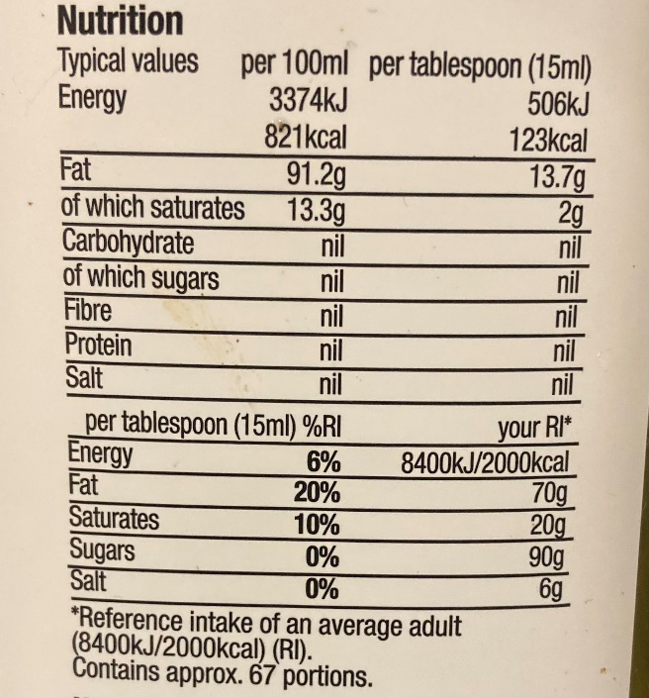
It's important to remember that a manufacturers portion size may be different to your own, which can sometimes make a product look healthier than it is

Saturated fats per 100g | Total fats per 100g | Total sugars per 100g | Salt per 100g
High (more than 5g) | High (more than 17.5g) | High (more than 22.5g) | High (more than 1.5g)
Low (less than 1.5g) | Low (less than 3g) | Low (less than 5g) | Low (less than 0.3g)
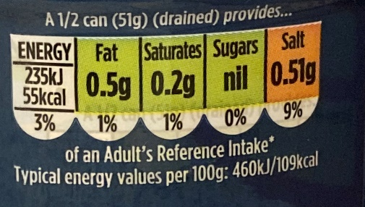
Some manufacturers use the traffic light system, this tells us quickly if a product has high (indicated though red), medium (indicated through amber), or low (indicated through green) amounts of fat, saturated fats, salt, and sugars.

- Highlighted allergies are listed within the ingredients, usually in bold, italics, or a larger font
- Ingredients are listed in descending order of weight at the time they were added, making it easier to spot when a food product is high in certain ingredients or nutrients

