Turkey Fajitas
1.Get ready  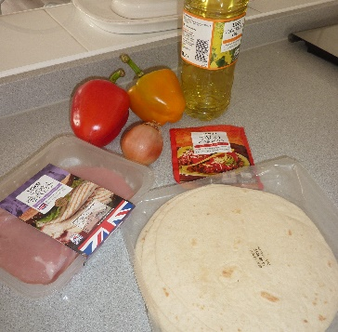Wash your hands.  Assemble ingredients | 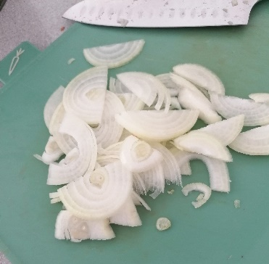Peel and slice the onion. | 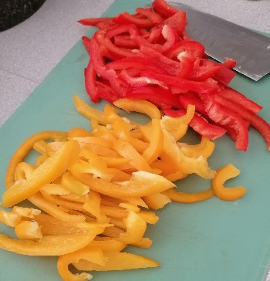Wash and slice the peppers.
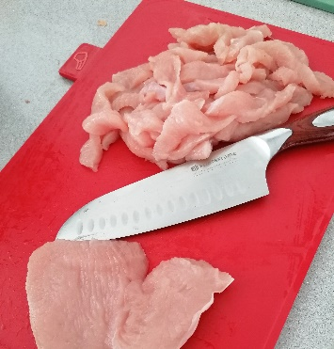Cut the turkey into thin strips. | 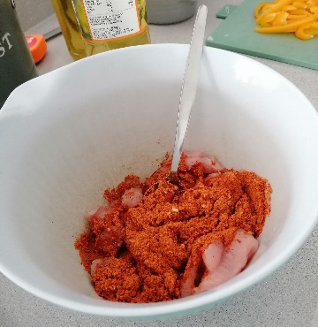Coat the turkey in oil and seasoning mix. | 2. Get cooking  Heat the oil in a heavy-based frying pan.
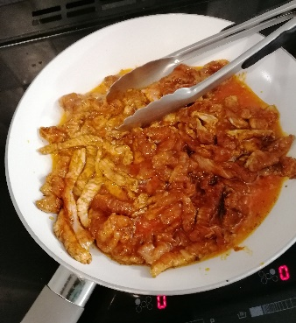Fry the turkey for three minutes until well browned. | 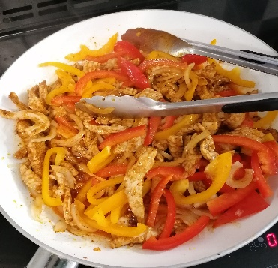  Add onion and peppers. Cook for 2 more minutes or until the meat is cooked. | 3. To serve  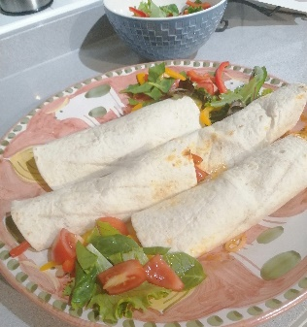Warm the tortillas, and wrap the turkey mixture into each of them.
Serve with salad, guacamole and soured cream

Ingredients List
Serves 4
450g boneless turkey, cut into thin strips
2 tbsp oil
1 sachet Fajita seasoning mix
1 onion, sliced
1 green pepper, sliced
1 red pepper, sliced
1 packet soft flour tortillas
Costings: £1.69 per serving (average supermarket pricing, March 2022)
Substitutions: swap out turkey for halloumi for a vegetarian option!
Nutritional Information:
Turkey is a great source of vitamin B, and protein, it actually has over half of what you need to grow big and strong in a day. Pepper is a fantastic source of vitamin C, which helps you to see everything around you.
Calories Kcal | 532
Fat | 17.1g
Saturated fat | 3.9g
Carbohydrates | 52g
Protein | 41.6g
Sugar | 3g
Salt | 0.92g
Fibre | 2.8g

