Tuna and Sweetcorn Pasta Bake
1.Get ready  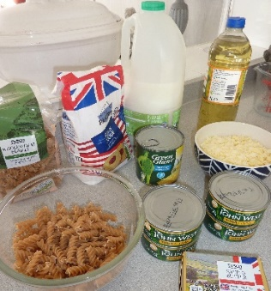  Wash your hands.  Weigh out ingredients.  Turn on the oven to 180C (fan160C). | 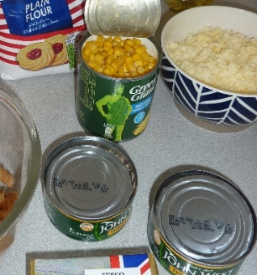Carefully open the tins and drain the sweetcorn and the tuna.. | 2. Cook the pasta  Half fill a large saucepan with water, add the pasta and a little salt.  Bring to a boil. Cook as in instructions on packet.  Drain.
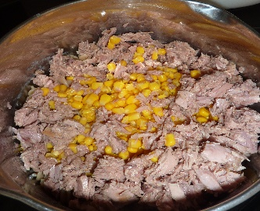Add the tuna and sweetcorn to the saucepan, and mix well with the pasta. | 3. Make the sauce  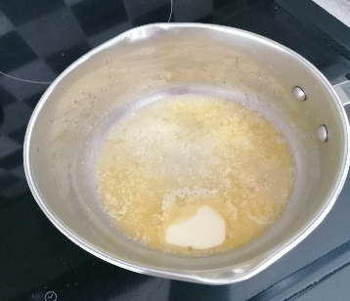Melt the butter in a medium saucepan. Add the flour and cook for one minute. | 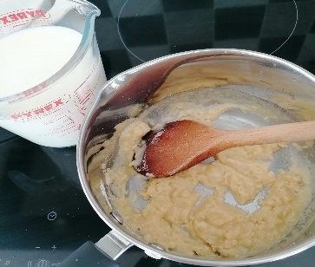  Stir in the milk a little at a time to make a thick white sauce.
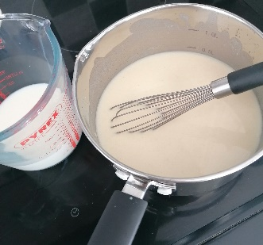Use a small balloon whisk to get rid of any lumps. | 4. Put it all together  Remove the sauce from the heat. Stir in 250g of the cheese and the pasta mixture. | 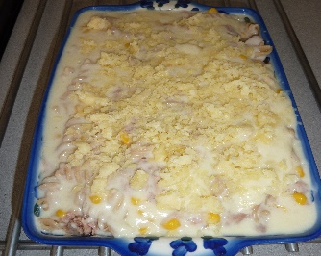Transfer the pasta mixture to a baking dish. Pour over the sauce. Top with the remaining cheese.
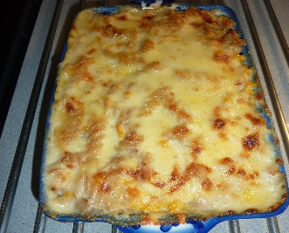Bake in the oven for 15-20 minutes until cheese on top is golden and starting to brown.
Ingredients List
Serves 4
200g dried pasta
Shapes

50g butter
50g plain flour
600ml milk
350g cheddar cheese, grated
320g tin of sweetcorn, drained
2 x160g tin of tuna, drained
Salt and pepper

Costings: £2.55 per a serving (average supermarket pricing, March 2022)
Substitutions: swap the tuna for canned beans for a vegetarian option!
Nutritional Information:
Calories Kcal | 826
Fat | 43.6g
Saturated fat | 23.42g
Carbohydrates | 53.6g
Protein | 53g
Sugar | 12.8g
Salt | 0.6g
Fibre | 2.9g
Tuna is a great source of vitamin D, helping to keep your bones strong. Sweetcorn has plenty of fibre to help keep you full and to help break down your food into little pieces in your tummy.

