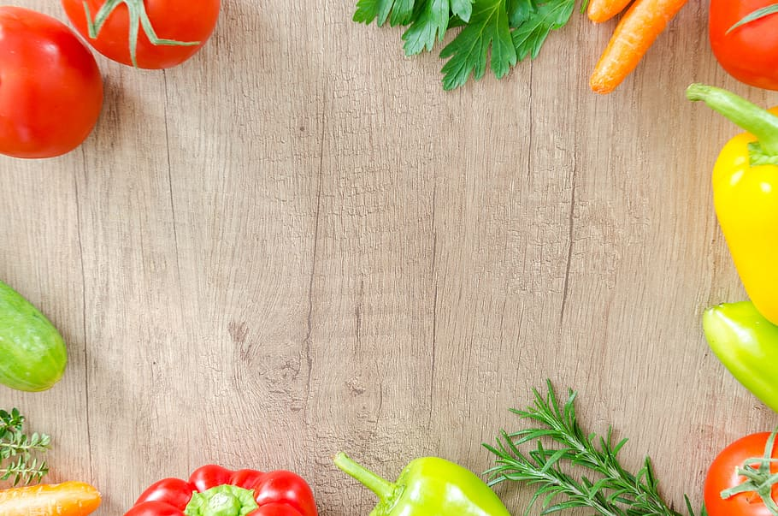
Teaching your Children about Nutrition: Common issues and solutions
It can feel challenging trying to teach your children about nutrition, and establishing positive eating habits. Children often go through stages of fussy eating, how this behaviour is combatted can impact your children’s eating habits later in life.
A good way to teach your children about nutrition is without prejudices, focus on descriptions of the foods, and then introduce descriptions of what the foods or parts of the foods can do for us. Teaching children about the differences between protein, carbohydrates, and fats, and how foods fit into these groups, whilst emphasising that each have their own strengths and can feel different for your body can be a great way to introduce the basics. Keep it simple, and tailor it depending on their age, and remember younger children tend to understand concepts in a literal manner.
Encouraging open discussions on foods can also be a much more effective way to teach nutrition then talking at them. Ask your children questions to keep them engaged and give them a sense of choice.
Finally, as always cooking with your children is a powerful tool for encouraging positive eating habits and an opportunity to talk about nutrition. Similarly, planting a garden will have positive effects and teach your children a valuable life skill.

1

THE CHRISTCHURCH FOOD FESTIVAL EDUCATION TRUST: CHARITY NUMBER: 1127292
BOURNEMOUTH UNIVERSITY: MSC NUTRITION AND BEHAVIOUR STUDENT: CAITLIN

2
Common Issues
Children refusing to eat certain foods:
Pressuring your children to eat certain foods can actually make the food less desirable, so they are less likely to eat it next time. Introducing foods gradually over time is essential with children, as new tastes and textures can feel overwhelming, remember they are new to food, and don’t have the experience an adult will have. Allowing children, a variety of flavours and textures when they are young, will also encourage them to enjoy a varied palette as they get older. Remember to praise your children when they try new foods, that will encourage them to do it again next time.

Children preferencing unhealthy foods:
First and foremost, remember that your own eating behaviours impact your children’s, if they see you enjoying the foods you want them to eat, they are more likely to develop a positive association with it, whilst if they see you adopting negative habits, such as talking negatively about yourself or obsessive dieting, your children may adopt similar attitudes and have a negative relationship with food. Additionally, labelling foods as ‘healthy’ and ‘unhealthy’ introduces moralistic standards to foods, which can make them feel guilty or bad about themselves when they enjoy it. Try to focus on neutral language when you talk about food.

THE CHRISTCHURCH FOOD FESTIVAL EDUCATION TRUST: CHARITY NUMBER: 1127292
BOURNEMOUTH UNIVERSITY: MSC NUTRITION AND BEHAVIOUR STUDENT: CAITLIN

3
Pressuring your children to eat more then they want:
Pressuring your children to eat more can actually encourage your children to ignore their hunger cues about satiety and hunger, which may lead to abnormal eating behaviours and weight issues in the future. Remember children need much smaller portions than adults, always keep this in mind when you prepare their food.

Restricting access to foods:
Restricting foods can make the food more desirable, even though it may seem counter intuitive banning certain foods can make your children crave them more, similarly setting time parameters, like ‘you can only have it once a week’ or making your child earn these foods, can have similar impacts.

THE CHRISTCHURCH FOOD FESTIVAL EDUCATION TRUST: CHARITY NUMBER: 1127292
BOURNEMOUTH UNIVERSITY: MSC NUTRITION AND BEHAVIOUR STUDENT: CAITLIN

Using food as a reward:
Although it can sometimes seem like the only option, using food as a reward for certain ‘good’ behaviours can negatively impact your child from developing preferences and healthy eating behaviours and attitudes. Conversely, if you are using it to encourage your child to eat foods they don’t want, it may reinforce the idea that the food is undesirable. Try tangible objects or experiences, such as a sticker.

