1.Get ready  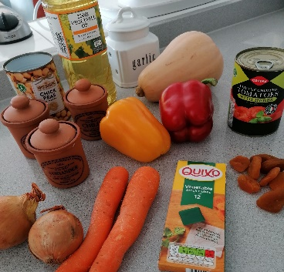  Wash your hands.  Set out your ingredients. | Slice the peppers and set aside | 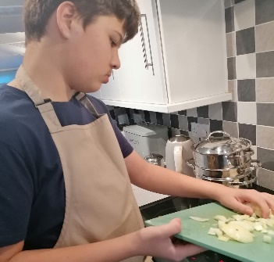  Prepare the sliced onions
2. Start cooking  Heat the oil in a large frying pan, and add the onions | Peel and chop the garlic cloves; add them to the pan | Add the spices to the pan.
3. Add more ingredients  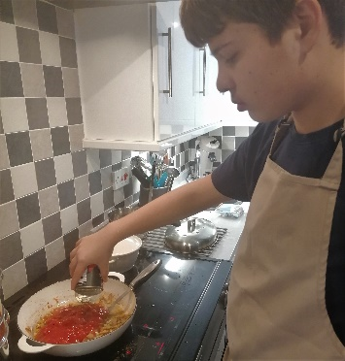  Add the canned tomatoes to the pan | 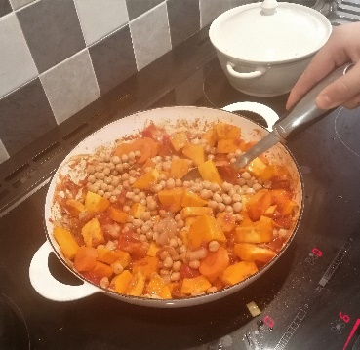  Add the chickpeas, the butternut squash, and the apricots | Now add the chopped peppers, and give the mixture a good stir
4. The final stage  Add the stock to the pan, stir, and cook for a further 45 minutes | 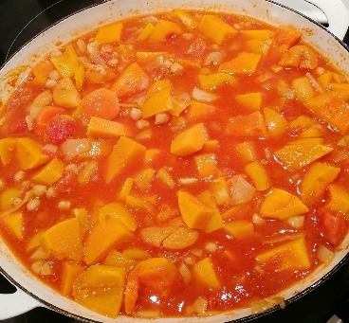  The tagine partially cooked | 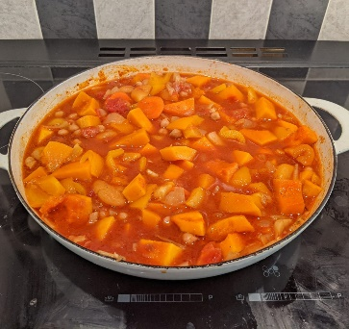  The cooked tagine ready to serve
Summer Vegetable Tagine
Ingredients List
Serves 4

1 yellow pepper

1 red pepper

1 tbsp oil

2 onions

2 garlic cloves

½ tsp chilli powder

½ tsp turmeric

2 tsp ground coriander

400g can tomatoes

250g butternut squash, peeled, de-seeded, and cut into chunks

400g can chickpeas

40g ready-to-eat dried apricots

600ml vegetable stock

Substitutions: add your favourite fillets of fish for extra protein!
Nutritional Information:
Pepper is a fantastic source of vitamin C, which helps you to see everything around you. Tomatoes and carrots are a great source of vitamin A, to help keep colds and sick bugs away. Butternut squash helps your body to break down your food in your tummy.

Calories Kcal | 251
Fat | 5.8g
Saturated fat | 0.7g
Carbohydrates | 42.9g
Protein | 8.5g
Sugar | 17.4g
Salt | 0.5g
Fibre | 8.4g

