Store Cupboard Essentials
1
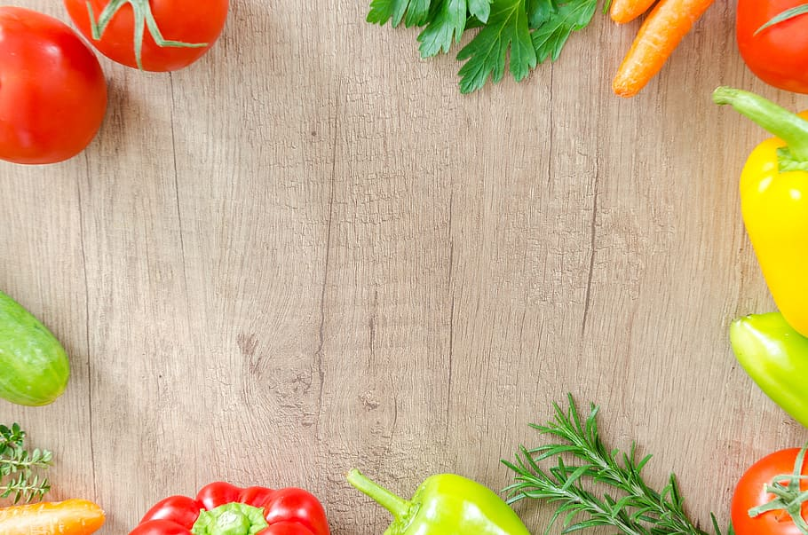
It’s easy to feel overwhelmed when you’re trying to fill up your shelves, but once you’ve got the basics, food shopping will become quicker and cheaper, not to mention it will make cooking much easier.
Pantry Goods
- Cooking oils e.g., olive oil
- Stock cubes
- Salt
- Pepper
- sugar
- Dried pasta
- Dried rice
- Oats- these can be great for a breakfast in a pinch, making porridge, muffins, muesli or for baking
- Flour- it’s cheapest to buy plain and then add baking powder when a recipe calls for self-raising, then you can use it for cooking dishes too, like to thicken stews and sauces
- Canned chopped tomatoes- a great cheap way to bulk up meals and for a quick pasta sauce, just simmer it in a pan for 20 minutes with a half can of water and season
- Your favourite canned pulses and legumes e.g., kidney beans, chickpeas, cannellini beans, and lentils- pulses and legumes are a great way to add some quick protein to any meal
- Vinegar e.g., balsamic vinegar, or red wine vinegar- perfect for adding flavour, and works for a quick salad dressing
- Onion and garlic granules- an easy low effort way to add those flavours to any meal without the prep
THE CHRISTCHURCH FOOD FESTIVAL EDUCATION TRUST: CHARITY NUMBER: 1127292
BOURNEMOUTH UNIVERSITY: MSC NUTRITION AND BEHAVIOUR STUDENT: CAITLIN

- Tinned fish e.g., tuna
2
- Baking powder- a leavening agent useful for lots of baking recipes
- Herbs e.g., oregano, basil, parsley, and thyme- great for adding seasoning to any dish
- Spices e.g., cumin, coriander, paprika, and cinnamon
Freezer and Fridge Goods
- Bread- you can take slices out at a time or the whole loaf depending on what you’re using it for
- Frozen peas and veg- great for a snack or to add to your meals
- Frozen fruit and berries- they’re great for baking, adding to your breakfast, or for making a quick dessert
- Unsalted butter- having a block of butter in the fridge can be great for cooking and baking
- Lemon juice- another great low effort solution when a recipe calls for lemon, just make sure you store it in the fridge once opened
THE CHRISTCHURCH FOOD FESTIVAL EDUCATION TRUST: CHARITY NUMBER: 1127292
BOURNEMOUTH UNIVERSITY: MSC NUTRITION AND BEHAVIOUR STUDENT: CAITLIN

