How to Follow a Sustainable Diet
1
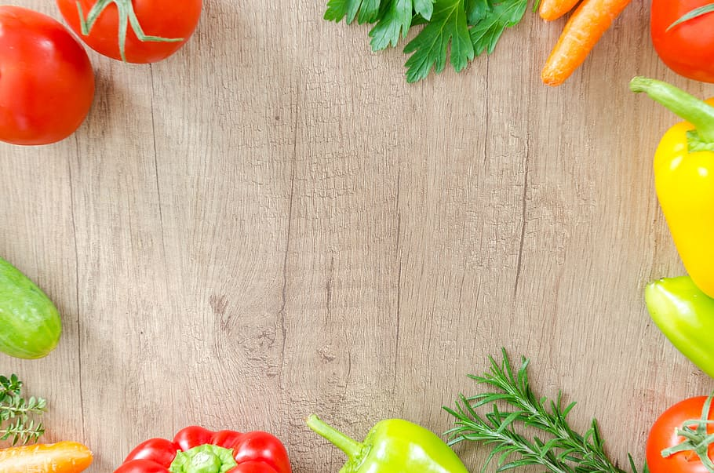
Sustainable simply means something that can be maintained. Sustainable diets aim to; be better for the environment and more protective, whilst being economically and socially accessible, fair, and affordable.
Meat your veg:
- Try to eat more variety of meats and veg
- Try to eat locally, meat that has been industrially farmed requires a lot of energy to produce
- Grow your own fruits, vegetables, and herbs to make a big difference. It’s also more nutritious as it won’t go through the lengthy process of harvesting and transportation
- Try meatless Mondays, to take a dip into vegetarian and vegan meals. If every family in the UK replaced a red meat meal with a plant-based meal just once a week, it would have the same environmental benefit of taking 16 million cars off the road
- If you can’t go meatless just yet ,always buy free range organic meat, as pasture-raised livestock have less of a negative environmental impact and are treated more humanely
Food waste: One third of all food produced globally is lost or wasted
- Make your freezer your friend: you can freeze anything from leftovers to fruits, most things are able to be frozen, and some can even be cooked from frozen, like bread, most toasters have a defrost function
- Where possible buy loose produce, so that you only buy the amount you will use
- Meal plan and make grocery lists to avoid overbuying and save money
- Know the difference between best before dates and use by dates, to reduce unnecessary food and money waste
- Utilise online recipes that use leftovers, they allow you to create entirely new dishes, whilst saving you money
THE CHRISTCHURCH FOOD FESTIVAL EDUCATION TRUST: CHARITY NUMBER: 1127292
BOURNEMOUTH UNIVERSITY: MSC NUTRITION AND BEHAVIOUR STUDENT: CAITLIN

- Always use your food waste bin if you have one, or go one step further and start a compost pile in your garden
2
- There are apps that are designed to reduce food waste, whilst also saving you money. Try an app like Too Good To Go, which links consumers with restaurants and shops that sell excess food at discounted prices to avoid food waste. Try an app like Olio, which allows users with excess home-grown produce, food nearing its use by date and unwanted food to be given to someone else in your community
Use leftovers: Use leftovers that often sit in the fridge
- Use them to make soups, add to pasta dishes or salads. Add an extra ingredient such as lentils and tomatoes to left over mince and make a cottage pie or a bolognaise sauce.
You may not always feel like using your leftovers in meals and there may not be enough. You can freeze some ingredients for later use. For instance:
- Hard Cheeses can be grated and frozen.
- Leftover herbs and be chopped and put into ice cube trays and frozen to be added to casseroles later.
- Double cream can be added to a sauce or lightly whipped and frozen.
- Bread can be whizzed in a food processor, sealed in a plastic bread and frozen.
- Left over olives can be used in a salad or added with an onion and a tin of tomatoes and served with pasta.
Sustainable Shopping:
- Buy food that meets certified standards: look for products certified as fair-trade to protect farmers and workers in developing countries, freedom food for animal welfare, RSPO certified sustainable palm oil, MSC and ASC certified for sustainably fished seafood
- Unsustainable palm oil sources are responsible for extensive deforestation, putting wildlife under significant threat and contributing to greenhouse gases. However, rejecting palm oil completely may lead to the use of worse alternatives, so RSPO certified palm oil is always best
THE CHRISTCHURCH FOOD FESTIVAL EDUCATION TRUST: CHARITY NUMBER: 1127292
BOURNEMOUTH UNIVERSITY: MSC NUTRITION AND BEHAVIOUR STUDENT: CAITLIN

- Buy organic - organic foods are grown and processed using farming methods which promote biodiversity and recycle resources, without using synthetic pesticides
3
- Where possible eat seasonally, from your local greengrocer or farm shop where possible, otherwise they’ll likely have been flown from around the world or grown in hot houses if in this country, which are both unsustainable and compromise in flavour
- Diversify your sea food to reduce the pressure on more over fished fish
- Buy locally, to support UK farms and fisheries and reduce your food mileage
- There are many apps now that help you to assess whether food products are environmentally sound, such as Giki
The plastic problem: Only one third of plastic packaging is currently recycled in the UK. Additionally, by 2050, the oceans could contain more plastic than fish
- Bring a reusable bag when you go shopping
- opt for packaging free fruits and veg
- You can now recycle plastic bags and most stretchy plastics, as well as pet food pouches and crisp packets at most major supermarkets
- Avoid single use plastics for storing your food, like cling film and instead store it in reusable boxes or with beeswax wraps to keep food fresh
THE CHRISTCHURCH FOOD FESTIVAL EDUCATION TRUST: CHARITY NUMBER: 1127292
BOURNEMOUTH UNIVERSITY: MSC NUTRITION AND BEHAVIOUR STUDENT: CAITLIN

THE CHRISTCHURCH FOOD FESTIVAL EDUCATION TRUST: CHARITY NUMBER: 1127292
BOURNEMOUTH UNIVERSITY: MSC NUTRITION AND BEHAVIOUR STUDENT: CAITLIN

