Healthy Burgers
Ingredients List
Makes 4 burgers
1.Get ready  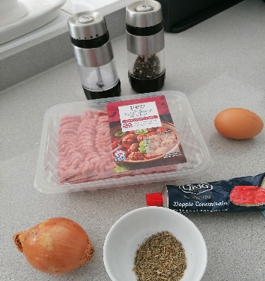Wash your hands. Assemble ingredients. | Finely chop the onion. | Beat the egg.
2. Mix it up  In a bowl mix the minced beef, onion, herbs, tomato puree and the beaten egg. | 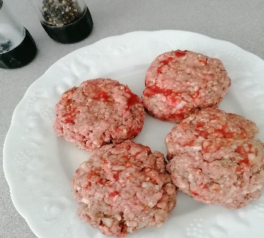Season with salt and pepper. Shape the mixture into 4 rounds about 2cm thick. | 3. Get cooking  Preheat the grill or a griddle pan. Cook the burgers for 4-6 minutes on each side.
Serve on a plate, or in a sliced bun as preferred.

450g lean minced beef

1 onion, very finely chopped

1 tablespoon dried mixed herbs

2 tablespoons tomato puree

I medium egg, beaten

Ground black pepper

Nutritional Information:
Beef is great for helping you to grow stronger and keeping you healthy. It can also help you to move faster and stay active.
Calories Kcal | 324
Fat | 23.6g
Saturated fat | 10.7g
Carbohydrates | 6.3g
Protein | 21.7g
Sugar | 3.3g
Salt | 0.5g
Fibre | 1.2g

