Fast Mac n Cheese
1.Get ready  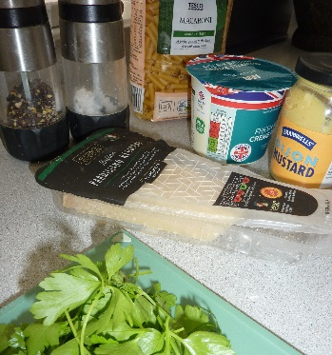Wash your hands.  Assemble ingredients. | 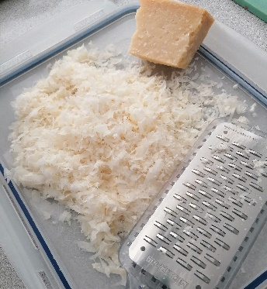  Weigh out and grate the cheese. | 2. Cook the macaroni  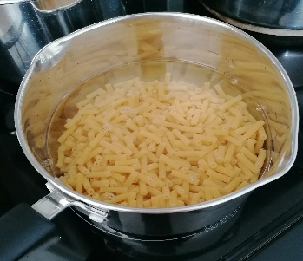Half fill a large sauce-pan with water; add the pasta and a little salt. Bring to the boil
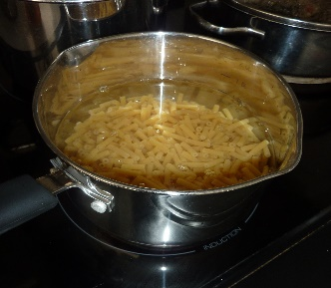  Cook following instructions on the packet. Drain and put to one side. | 3. Put it together  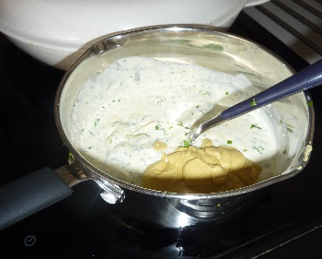  Put the crème fraiche, mustard, and parsley into a pan and heat gently. | 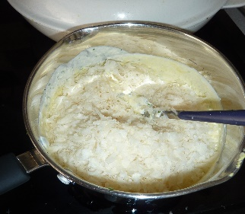  Add 175g of the cheese, and season well with black pepper.
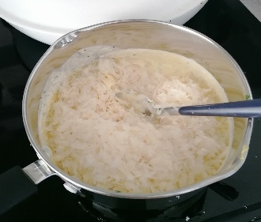  Stir the cooked pasta through the sauce | 4. To serve  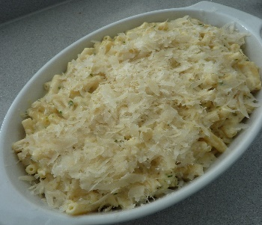Spoon into an ovenproof dish and sprinkle with the remaining cheese. | 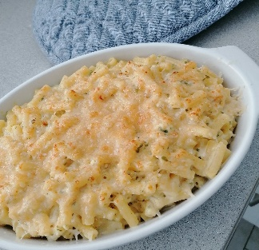Place under a hot grill (not too close to the element) until golden brown.
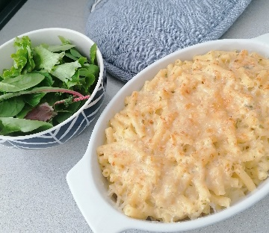Serve immediately with a green salad.
Ingredients List
Serves 4

500g dried macaroni
2 x 500ml low fat crème fraiche
200g freshly grated parmesan cheese
2 tablespoons ready-made mustard (English or Dijon)
5 tablespoons, chopped parsley
Salt and Ground pepper
Green salad to serve

Substitutions: add some shredded ham or canned beans for extra protein!

Nutritional Information:
Cheese gives you calcium, which is great for growing your bones. Pasta gives you lots of energy, to keep you moving throughout the day.
Calories Kcal | 729
Fat | 39.4g
Saturated fat | 5.5g
Carbohydrates | 67.7g
Protein | 25.6g
Sugar | 3.1g
Salt | 0.3g
Fibre | 3.3g

