Equipment to get you Started: Top 10
1
These 10 pieces of equipment will make life much easier when you’re learning to make your own great food, but don’t feel like you must buy them all at once, consider what you’ll use most and go from there.

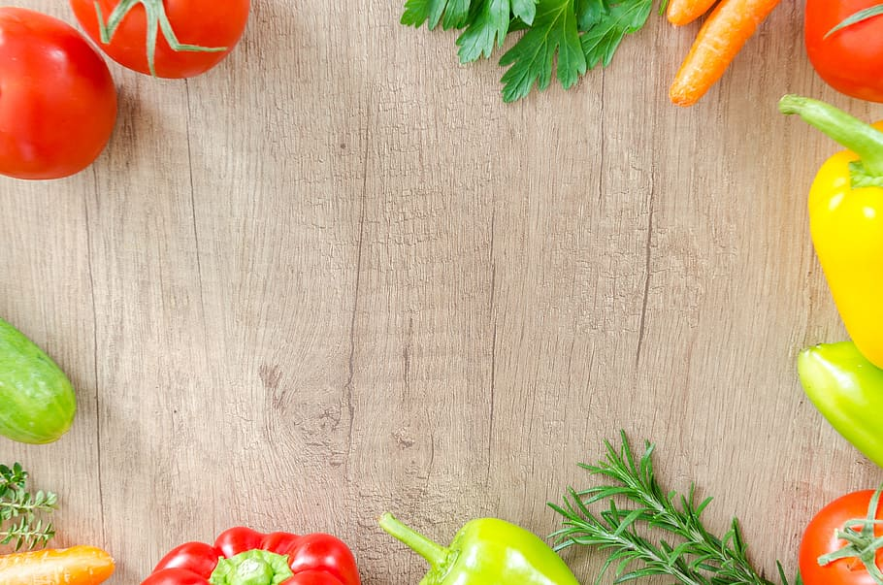

- Knives- one smaller such as a parring knife and one large chefs’ knife, although if you can’t afford both go for the chef’s knife as an all-purpose blade
- Chopping board- wooden is best, but plastic will also work without damaging your knives
- Saucepans- preferably non-stick to make clean-up easier, one medium and one large is best, and the most versatile options, they also often come in easy sets at the supermarket
- Frying pan- go for one 24-28cm pan, preferably non-stick with a reasonably heavy base, as it will last longer and cook more evenly
- Utensils- these often come in sets at the supermarket and are relatively cheap to buy, including, a wooden spoon, spatula, serving spoon, ladle, whisk, peeler, can opener and tongs
- Baking trays- two medium to large should cover most of your cooking needs initially
- Colander- stainless steel is best and will last forever with good care
- Grater- a grater with multiple sides for different sizes is best for versatility
- Scales- electronic is preferable and will make baking and portioning much easier
- Roasting tray- opt for glass or ceramic to double as a dish for pies and stews
THE CHRISTCHURCH FOOD FESTIVAL EDUCATION TRUST: CHARITY NUMBER: 1127292
BOURNEMOUTH UNIVERSITY: MSC NUTRITION AND BEHAVIOUR STUDENT: CAITLIN

