1.Get ready  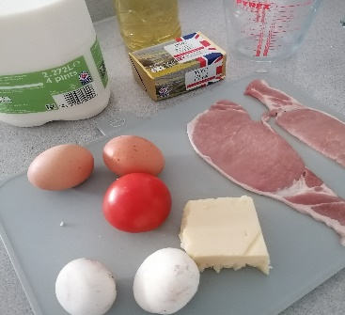Wash your hands.  Set out your ingredients. | 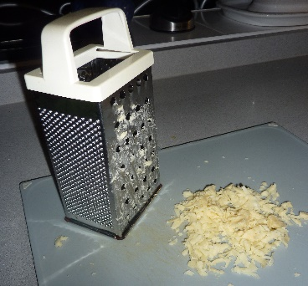  Weigh out and grate the cheese. | 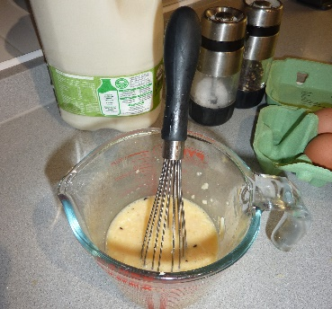  Whisk the eggs and milk together in a jug. Add the cheese and season with salt and pepper.
2. Prepare the filling  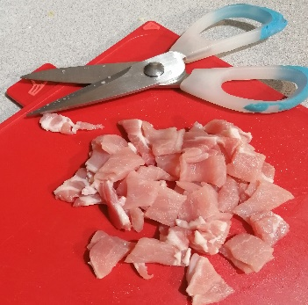  Cut the bacon into cubes. | Cut the tomato into chunks. | 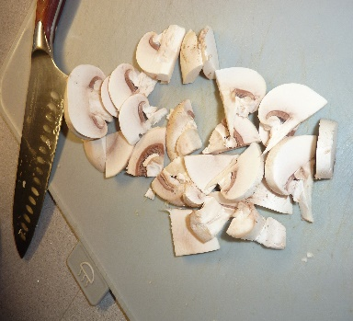  Slice the mushrooms.
3. Cook the filling  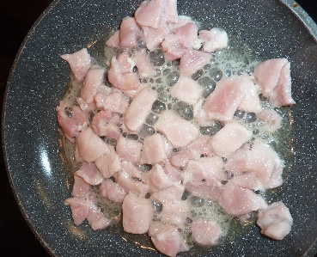Place a frying pan over a medium heat, fry the bacon for 3 minutes or until cooked; tip onto a plate lined with kitchen paper | Heat the oil and fry the mushrooms for 2 minutes. Add the tomato. Place on to a plate and add the bacon. | 4. Make the omelette  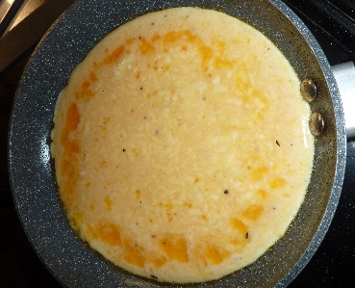Melt the butter in the pan. Pour in the egg mixture so that it covers the base of the pan.
Cook the egg on a medium heat until the edges begin to cook and set.  Using a spatula push the cooked egg into the centre of the pan. The uncooked egg will run to the sides. Repeat until all the egg is cooked | Spoon the filling to one half of the omelette and gently flip the other half over the top. | The finished omelette!
Breakfast Omelette
Ingredients List
Serves 1
2 eggs
2 tbsp milk
30g Cheddar Cheese, grated
A knob of unsalted butter
Salt and pepper

For the filling:
2 rashers of bacon, de-rinded
1 tomato, cut into chunks
1 tsp of sunflower oil
30g mushrooms, sliced

Costings: £1.80 per serving (average supermarket pricing, March 2022)
Substitutions: omit the bacon for a vegetarian option or change up the fillings for any of your favourites!
Nutritional Information:
Eggs will give you lots of strength. Mushrooms are good for your heart and keeping things like colds away. Cheese gives you calcium, which is great for growing your bones.
Calories Kcal | 526
Fat | 41.9g
Saturated fat | 19.6g
Carbohydrates | 8g
Protein | 51.5g
Sugar | 5g
Salt | 1.6g
Fibre | 2.3g

