8 Healthier Alternatives and Swaps
1
Changing aspects of you or your children’s diet can feel overwhelming, starting with smaller changes can feel more manageable, and can have major benefits to your overall health and risk of disease.

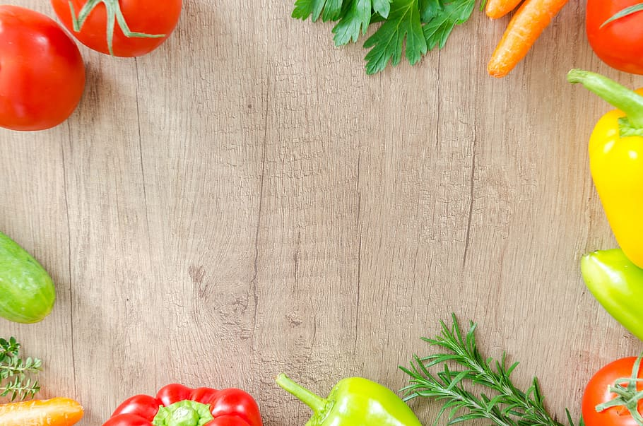

- Swap white breads, pastas, and rice for wholegrain and wholemeal varieties- they are high in fibre which help you to feel full. They are also linked to lower risk of health problems.
- Swap shallow and deep-fried foods for baked- it will require less oil for cooking, which would otherwise be absorbed into your food, increasing fat content and caloric consumption.
- Swap flavoured porridge for plain oats- you can add fruit and honey for sweetness. Flavoured oats are packed with sugar and decreased nutritional value. Plain oats are a great source of fibre, vitamins, and minerals. Additionally, they reduce cholesterol levels and blood sugar levels.
- Swap bagged popcorn for popcorn kernels- you can add the flavours you’re craving in moderation for a nutritious snack. Popcorn is a source of fibre and antioxidants, and can improve digestive health.
- Swap crisps for homemade veggie crisps or roasted chickpeas- it’s a great way to add to your 5 a day, whilst chickpeas are high in protein and a great source of vitamins and minerals.
- Swap sweets for dark chocolate-covered fruit or dried fruits- dark chocolate is high in antioxidants and contains less sugar than milk chocolate. Whilst dried fruit consumption has been linked to lower risk of disease and are full of healthy nutrients.
- Swap flavoured yoghurts with natural or Greek yoghurt- you can sweeten it with fruit and add texture with nuts, for reduced added sugars. Greek yoghurt is a good source of calcium and B vitamins.
- Swap granola for nuts for a topping- shop bought granolas can be very high in sugar, nuts will give you that crunch your after whilst being high in healthy fats and fibre. Additionally, research suggests that introducing nuts at an early age to children can reduce the risk of allergic reactions
THE CHRISTCHURCH FOOD FESTIVAL EDUCATION TRUST: CHARITY NUMBER: 1127292
BOURNEMOUTH UNIVERSITY: MSC NUTRITION AND BEHAVIOUR STUDENT: CAITLIN

