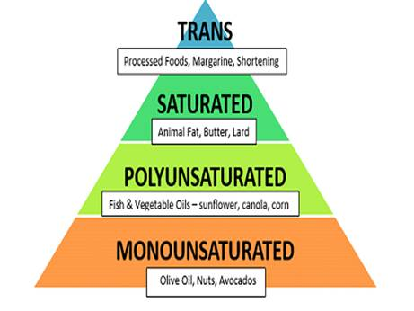

1. Some foods, including most fruits and vegetables, have almost no fat. Other foods have plenty of fat. They include nuts, oils, butter, and meats like beef.
2. Fat is used in the body as fuel and helps the body absorb the fat-soluble vitamins A, D, E and K.
3. Trans fat is unhealthy for health. Trans fats are found in stick margarine. Cookies, snack foods, cakes, fried foods contain trans fats. Trans fats are unhealthy because it can lead to heart diseases.
4. Saturated fats are solid at room temperature. Excessive saturated fat intake can effect on your health negatively.
5. Unsaturated fats are liquid at room temperature. Unsaturated fat found in plant foods and fish. Unsaturated fats are good for your heart health.

6. Fast-food and takeout meals tend to have more fat than home cooking, and in restaurants, fried dishes are the highest in fat content. Fat also often "hides" in foods in the form of creamy, cheesy, or buttery sauces or dressings.
7. Omega-3 fatty acids, a type of polyunsaturated fat found in oily fish like tuna and salmon. Omega 3 fatty acids are essential to play a role the development of central nervous system and cardiovascular system.

8. Healthy fats are necessary for the development of young child’s central nervous system, vision and intelligence. Children need healthy fats for growth and energy, also healthy fats supply the absorption and metabolism of some nutrients.

9. Walnuts, soybeans, flaxseeds (linseeds) are rich in omega- 3 fatty acids which are essential for brain development.

10. Fat also gives our foods a lot of their flavour and texture.

11. Avocado is source of healthy fat.

