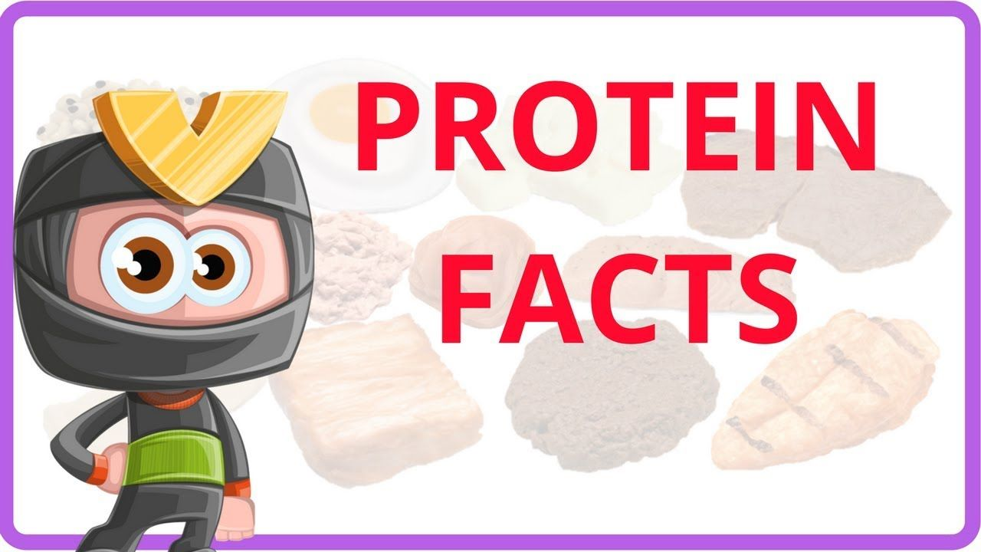

1. The fish with the most protein is Yellowfin Tuna.
2. Most beef has lower protein content than poultry or chicken.
3. Soybeans are protein-rich and contain 16.6g per 100g.
4. Eggs are one of the foods with the highest quality protein.
5. Parmesan cheese has highest protein content of all cheeses.
6. White and Brown eggs have the same nutritional value.
7. Pollen is full of protein which helps bees grow stronger.
8. If you eat meat, chicken, fish, eggs, nuts, dairy products and legumes, you likely consume enough protein.
9. If you are a vegetarian (don't eat animal foods), you need to eat a wide variety of plant foods.

10. Quinoa, pulses such as lentils, chickpeas, beans etc., tofu, nuts and seeds, Chia seeds, oats are high in protein. These foods can be good choices for vegans and vegetarians to get enough protein.
11. Quinoa, a grain-like crop contains all nine essential amino acids making it a good source of complete protein.

