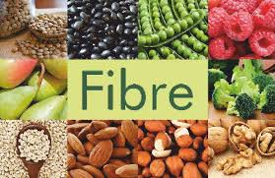

1. Recommended fibre intakes for boys and girls aged 2 to 5, 15 grams per-day.
2. Recommended fibre intakes for boys and girls aged 5 to 11, 20 grams per-day.
3. Recommended fibre intakes for boys and girls aged 11 to 16, 25 grams per-day
4. Fibre helps to maintain the ‘friendly’ bowel bacteria that are important to maintain a healthy digestive system.
5. Fibre is made up of some carbohydrates in plant foods.
6. Fibre is found in plant foods such as cereal grains, fruit, vegetables, nuts, seeds, beans and lentils.
7. Soluble fibres easily dissolve in water and gastrointestinal fluids. Soluble fibres separate into a gel-like substances in the large intestine.
8. Common sources of soluble fibre include oats, oat bran, barley, dried beans, peas, and certain fruits and vegetables, such as strawberries, apples, potatoes, citrus, and prunes.
9. While products, such as cookies, crackers, drinks, sugary cereals, and ice cream have started to include fibres to make them appear more healthful, naturally occurring fibre typically has the best health benefits.
10. Fruit and vegetable juices have less fibre than whole fruit and vegetables. This is because the skin is removed to make the juice. It is more healthful to eat whole fruit and vegetables than to drink fruit and vegetable juices.
11. Fruit is better than the juice. For example, a raw unpeeled apple has almost 10 times more fibre than a cup of apple juice.
12. Fibre cleans your colon, acting like a scrub brush.
13. Brown rice is brown because it still has the husk, which is the fibre. White rice does not have any fibre because the husks have been removed.

